Lab 1: Ubuntu on VirtualBox
1. NAT vs Bridge Networking
NAT (Network Address Translation)
Default network mode in VirtualBox.
VM gets a private IP assigned by VirtualBox.
VM can access the internet, but external devices cannot access the VM directly.
Useful for isolated setups where you do not want your VM exposed to the local network.
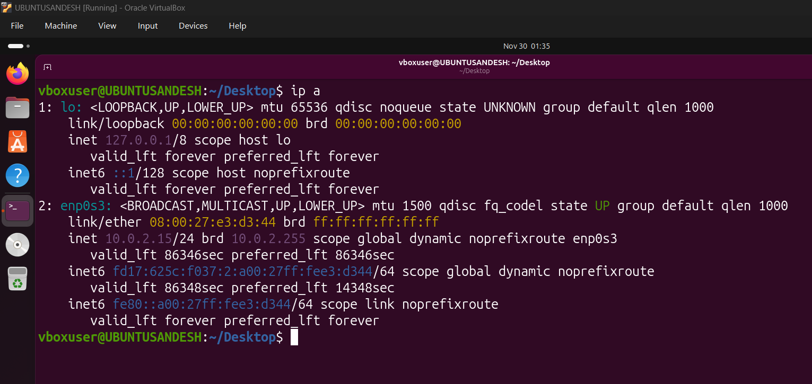
Bridge Mode
VM acts as a full device on the local network.
Gets an IP from the same router as the host machine.
Other devices in the network can ping or access the VM.
Useful for hosting services or testing server accessibility.
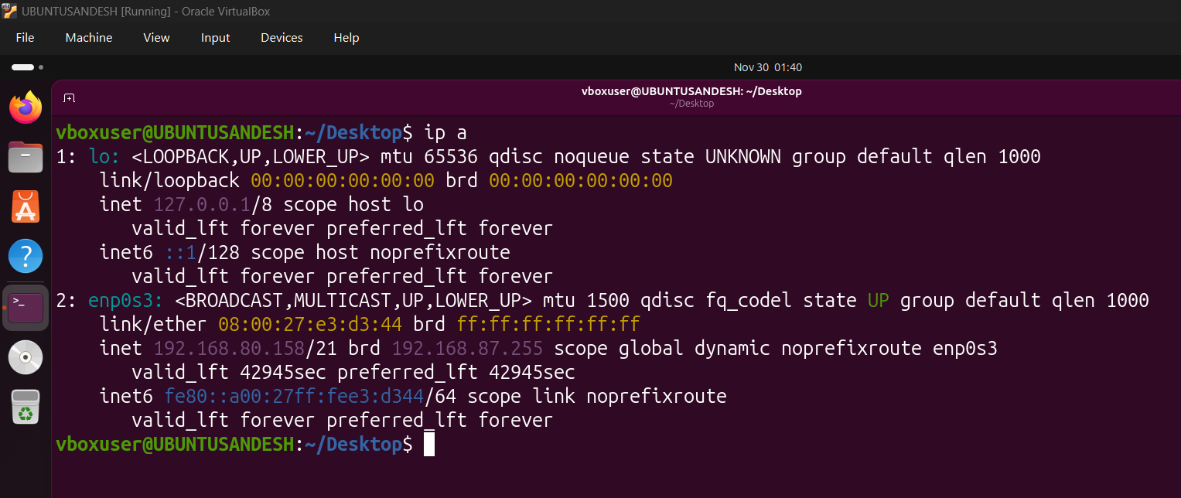

2. Basic Linux Commands Used
Command | Description
cd | Change directory
pwd | Show current working directory
mkdir <directory> | Create a new directory
touch <file> | Create an empty file
ls | List files and directories
nano <file> | Open file in nano editor (exit: Ctrl X)
cat <file> | Display file contents
rm <file> | Delete a file
ls -ltr | List with details sorted by time
rm <directory> | Fails if directory not empty
rm -rf <directory> | Force delete directory
df -h | Show disk/storage usage
free -mh | Show RAM usage
top | Show running processes

3. Absolute Path vs Relative Path
Absolute Path
Starts from root directory /.
Complete path to a file or folder.
Example: /home/user/documents/file.txt
Relative Path
Based on current working directory.
Example: ../folder/file.txt or ./file.txt

4. Use of Nginx on Ubuntu
Check if Nginx is running:
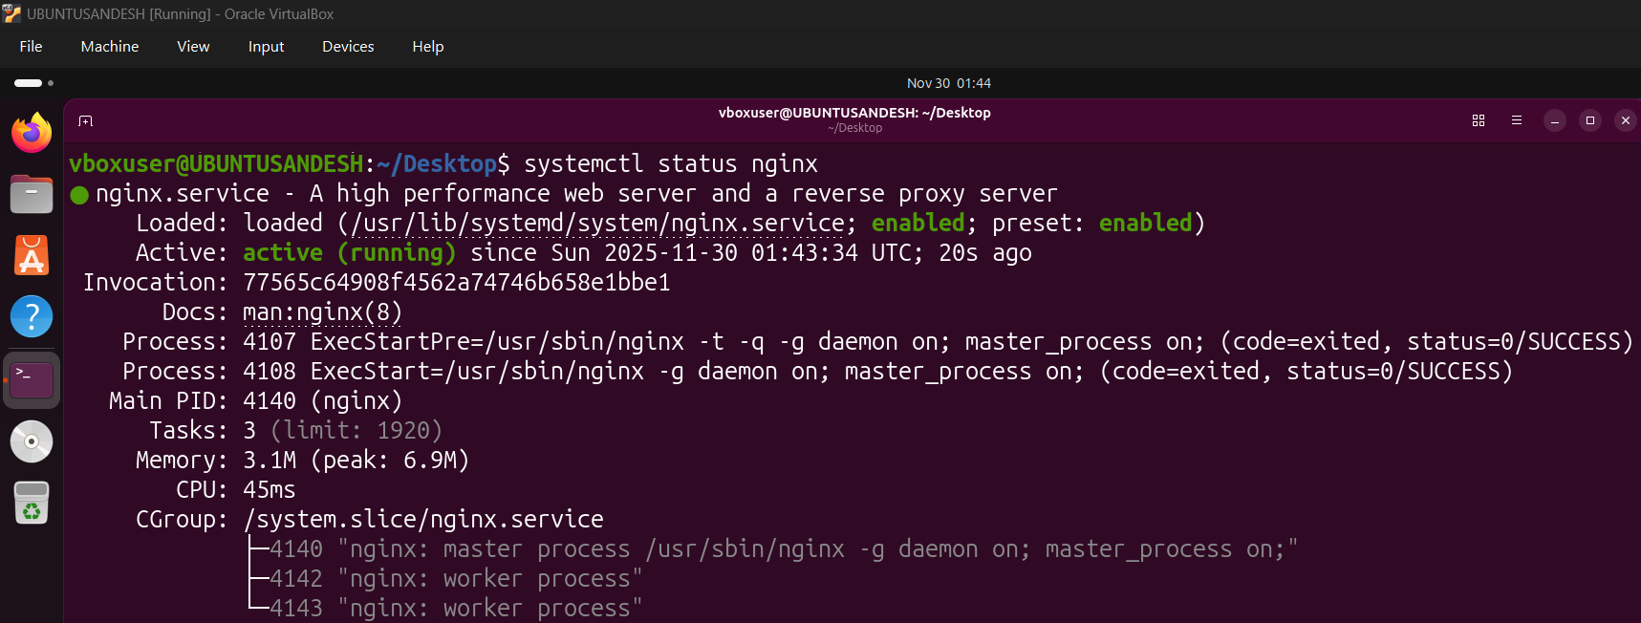
ps -ef | grep nginx
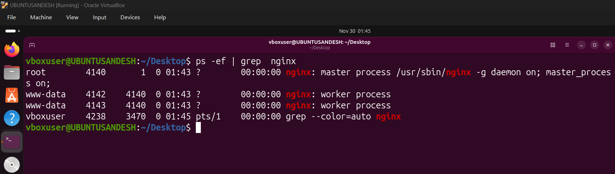
Install net-tools:
sudo apt install net-tools
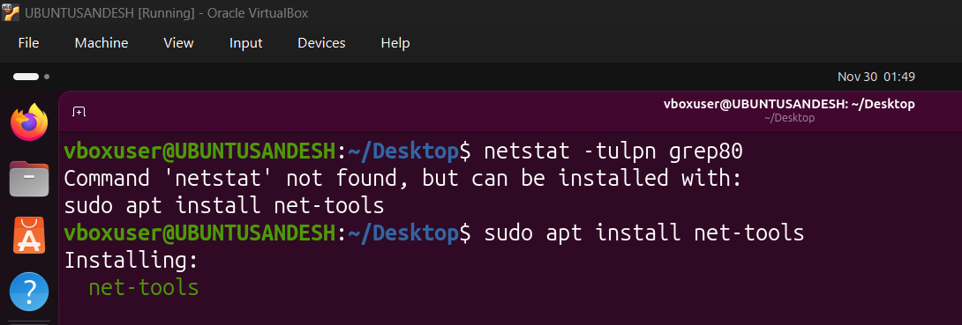
Check listening ports (for port 80 or 22):
netstat -tulpn | grep 80
netstat -tulpn | grep 22
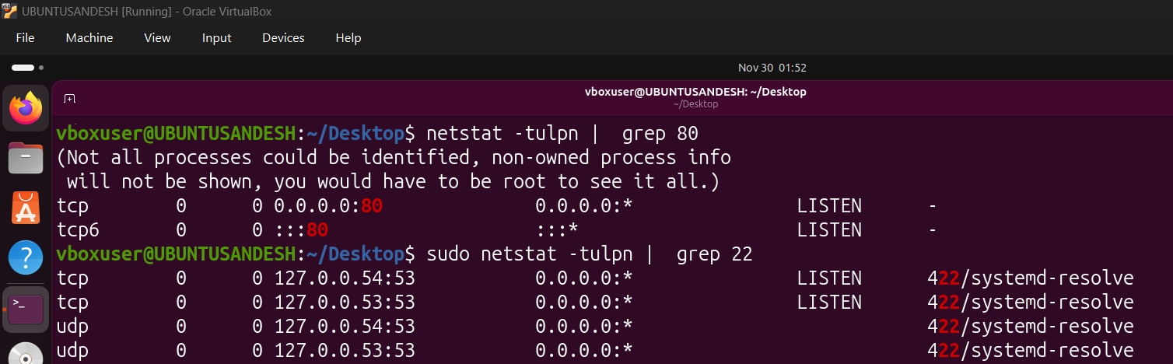

Final Summary
This lab focused on installing and working with Ubuntu inside VirtualBox. NAT and Bridge modes were compared, followed by hands-on use of basic Linux commands. Path concepts were clarified (absolute vs relative), and Nginx installation and network port checks were performed.

